Greenwich Student Quarter – RonaScreed 8 Day Overlay Fast Drying Screed

In brief

Over 3000m² of RonaScreed 8 Day Overlay Fast Drying Screed was laid by Ronacrete Approved Contractor CCS Drywall Limited at student accommodation in Greenwich. The screed was required to dry within 21 days so that floor finishes could be installed before term began.

The project
The specification for the new 358 bed student accommodation required screed to be laid on thermal insulation before the application of floor finishes. RonaScreed 8 Day Overlay Fast Drying Screed was specified for the project.

Product and application
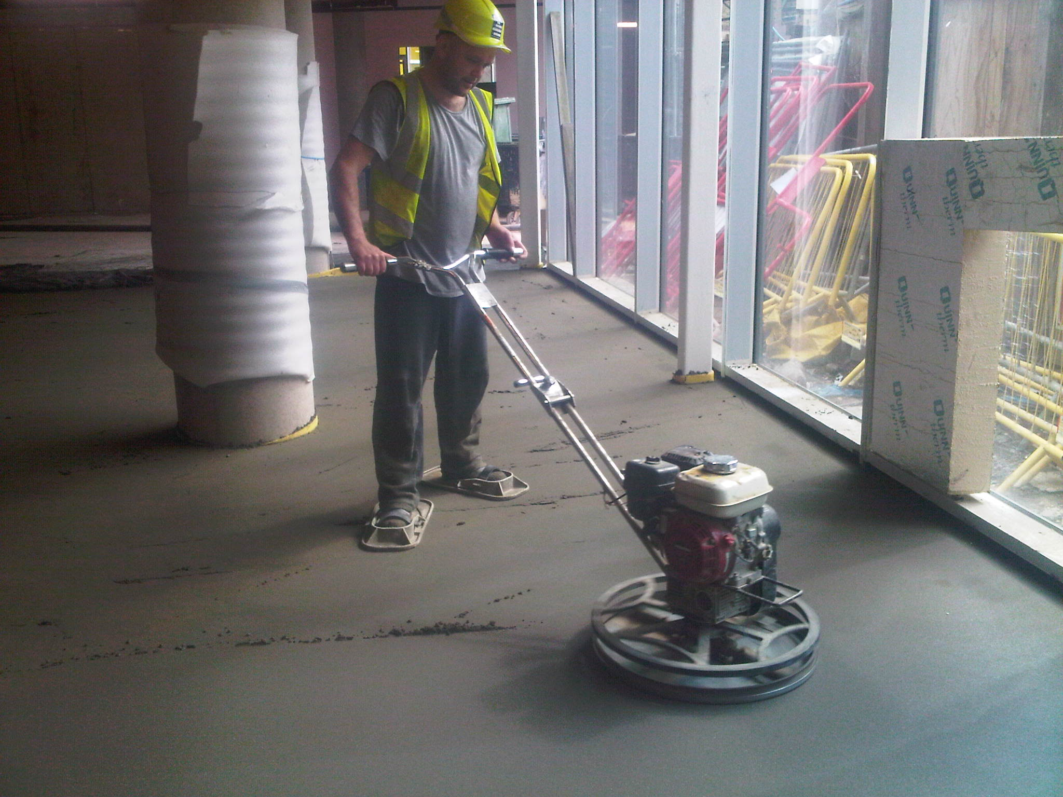RonaScreed 8 Day Overlay Fast Drying Screed was selected for its fast drying properties and for its suitability for use in a floating screed construction.
RonaScreed 8 Day Overlay Fast Drying Screed is also available in pre-packed form as RonaScreed 8 Day Overlay Pre-packed Fast Drying Screed.

RonaScreed 8 Day Overlay Fast Drying Screed is economical and ideal for fast-track projects like student accommodation, making it particularly suitable for large scale education, commercial, hospital, and retail projects.

Conclusion

The contractor ensured that the screed was dry before floor finishes were applied. Independent testing shows that a 50mm thick RonaScreed 8 Day Overlay Fast Drying Screed to Mix Design 1 reaches 75% RH after 8 days at 20ºC and 60% relative air humidity. Drying at a thickness of 75mm takes 15 days in the same conditions.

